**KRSTARENJE, 6 DANA / 5 NOĆI**

**POLASCI IZ DUBAIJA**

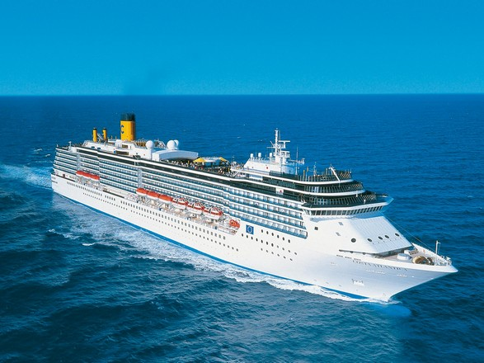

|  |  |  |  |  |  |  |  |  |  |  |  |  |  |  |  |  |  |  |  |  |  |  |  |  |  |  |  |  |  |  |  |  |  |  |  |  |  |  |  |  |  |  |  |  |  |  |  |  |  |  |  |  |  |  |  |  |  |  |  |  |  |  |  |  |  |  |  |  |  |  |  |  |  |  |  |  |  |  |  |  |  |  |  |  |  |  |  |  |  |  |  |  |  |  |  |  |  |  |  |  |  |  |  |  |  |  |  |  |  |  |  |  |  |  |  |  |  |  |  |  |  |  |  |  |  |  |  |  |  |  |  |  |  |  |  |  |  |  |  |  |  |  |  |  |
| --- | --- | --- | --- | --- | --- | --- | --- | --- | --- | --- | --- | --- | --- | --- | --- | --- | --- | --- | --- | --- | --- | --- | --- | --- | --- | --- | --- | --- | --- | --- | --- | --- | --- | --- | --- | --- | --- | --- | --- | --- | --- | --- | --- | --- | --- | --- | --- | --- | --- | --- | --- | --- | --- | --- | --- | --- | --- | --- | --- | --- | --- | --- | --- | --- | --- | --- | --- | --- | --- | --- | --- | --- | --- | --- | --- | --- | --- | --- | --- | --- | --- | --- | --- | --- | --- | --- | --- | --- | --- | --- | --- | --- | --- | --- | --- | --- | --- | --- | --- | --- | --- | --- | --- | --- | --- | --- | --- | --- | --- | --- | --- | --- | --- | --- | --- | --- | --- | --- | --- | --- | --- | --- | --- | --- | --- | --- | --- | --- | --- | --- | --- | --- | --- | --- | --- | --- | --- | --- | --- | --- | --- | --- | --- | --- |
| |  |  | | --- | --- | | ***DAN*** | ***LUKA*** | | **1.** | DUBAI | | **2.** | MUSCAT | | **3.** | MUSCAT | | **4.** | SIR BANI YAS ISLAND | | **5.** | ABU DHABI | | **6.** | DUBAI |  |  |  |  |  |  |  |  |  |  |  |  |  |  | | --- | --- | --- | --- | --- | --- | --- | --- | --- | --- | --- | --- | --- | | **DATUM POLASKA**  **DATUM POVRATKA** | **23.06.**  **01.07.** | **30.12.**  **07.01.** | **06.01.**  **14.01.** | **20.01.**  **28.01.** | **27.01.**  **04.02.** | **03.02.**  **11.02.** | **10.02.**  **18.02.** | **17.02.**  **25.02.** | **24.02.**  **04.03.** | **03.03.**  **10.03.** | **09.03.**  **29.03.** | | | **Broj dana / Broj noćenja** | **6/5** | | | | | | | | | | | | | **Luka Ukrcaja/Vrsta kabine** | **DUBAI** | | | | | | | | | | | | | **Costa MEDITERANEA, EMIRATI & OMAN, USLUGA FB (doručak+ručak+večera))** | | | | | | | | | | | | | | **1/2 unitrašnja kabina** | **559 €** | **619 €** | **709 €** | **759 €** | **809 €** | **879 €** | **559 €** | **619 €** | **709 €** | **759 €** | | **809 €** | | 1/2 unutrašnja klasik | **809 €** | **869 €** | **959 €** | **1009 €** | **1059 €** | **1129 €** | **809 €** | **869 €** | **959 €** | **1009 €** | | **1059 €** | | 1/2 unutrašnja premium | **319 €** | **379 €** | **419 €** | **469 €** | **519 €** | **589 €** | **319 €** | **379 €** | **419 €** | **469 €** | | **519 €** | | 1/2 spoljašnja sa prozorom | **319 €** | **379 €** | **419 €** | **469 €** | **519 €** | **589 €** | **319 €** | **379 €** | **419 €** | **469 €** | | **519 €** | | 1/2 spoljašnja sa balkonom | **319 €** | **379 €** | **419 €** | **469 €** | **519 €** | **589 €** | **319 €** | **379 €** | **419 €** | **469 €** | | **519 €** | | 1/2 suite | **319 €** | **379 €** | **419 €** | **469 €** | **519 €** | **589 €** | **319 €** | **379 €** | **419 €** | **469 €** | | **519 €** | |
|  |

***CENA UKLJUČUJE:***

* **krstarenje prema programu**
* **smeštaj u odabranoj kabini tokom krstarenja na brodu (kupatilo/WC, klima uredjaj, sef, fen, TV),**
* **proširen pun pansion na brodu (doručak, ručak, večera, užina),**
* **svečanu večeru uz kapetanovu zdravicu**
* **celodnevna animacija**
* **zabavni program u salonima i barovima**
* **korišćenje brodskih prostora i opreme (korišćenje fitnes centra, bazena, đakuzija, ležaljki…)**
* **predstave u pozorištu**
* **ulaznice za kockarnicu i noćne klubove**

***CENA NE UKLJUČUJE:***

* **prevoz do i od luke ukrcaja (može se rezervisati u agenciji ili putem linka** [**www.avio.rs**](http://www.avio.rs)**)**
* **transfere do luke ukrcaja i od luke iskrcaja**
* **napojnice ( 10EUR dnevno po osobi, deca od 2 do 13 godina 5EUR dnevno po osobi )**
* **pića na brodu i napojnice 15% od lične potrošnje**
* **fakultativne izlete,**
* **ličnu potrošnju,**
* **osiguranje-nije obavezno**
* **lučke takse u iznosu od 140 €**

U slučaju nedovoljnog broja prijavljenih putnika, rok za otkaz aranžmana je 5 dana pre puta.

ORGANIZATOR zadržava pravo korekcije cena usled promena na monetarnom tržištu ili promena cena smeštaja ili prevoza. ORGANIZATOR zadržava pravo izmene u programu putovanja

(redosled pojedinih sadržaja u programu usled objektivnih okolnosti).

Aranžman je rađen na bazi minimum 2 putnika.

Uz ovaj aranžman važe Opšti uslovi putovanja organizatora, usaglašeni sa YUTA standardom.

Organizator putovanja Fantast tourist d.o.o.,Jevrejska 8, Novi Sad. Licenca broj: OTP 152/2010

Prema Zakonu o turizmu organizator ima propisanu polisu osiguranja br 300055318 „DDOR“ a.d.o. Novi Sad.

Cenovnik broj 1 od 25.11.2016.